Orlando Brewery SalesForce.com App

Contents

Objective 1

Setup SFDC 2

1. Registering 2

2. Configuring the Cloud 2

Create SFDC Application 3

Create SFDC NamesSpace 6

Object Definition 8

Working with Data in SFDC 20

3. REST API and Developer workbench 27

Setup BlackBerry 10 Sample Project 28

Import Project into IDE 28

Update Project Source 28

Constants.h 29

Deploy, Test and Troubleshoot 29

# Objective

Since every good enterprise application interacts with off-device services, like in-house or third-party web services, understanding existing demos and sample projects is crucial. BlackBerry Live 2013 demonstrated the BlackBerry 10 Orlando Brewing SalesForce.com Application, which showcased how easy it is for organizations to leverage the BlackBerry 10 solution to interact with their everyday solutions.

The purpose of this document is to detail the steps needed in order to run the BlackBerry 10 Orlando Brewery SalesForce.com (SFDC) Application demo. The demonstration is composed of customizations of an SFDC cloud offering that interact with a BlackBerry 10 native application. The configuration of each part is detailed below. *(Note: Screen shots may differ based on product release and SFDC will be used instead of typing out SalesForce.com)*

# Setup SFDC

SFDC offers developers a development environment (“sandbox”) to build out their applications that interact with the cloud. This sandbox does have some dummy data you can work with, but for this application we went a bit further to match a more real enterprise scenario. This section walks you through how to recreate the SFDC cloud objects in order to properly interact with the BlackBerry 10 mobile application.

## Registering

To register, start by clicking on the “Join Now” button on this page: <http://developer.force.com/>

The email address you register with will be the one that we use both in the setup of the SFDC.com objects as well as some of the BlackBerry 10 application source. This way we know the demo will work if everything is matchy matchy. In a production environment, you may want to build extra workflow to make a rocking user experience.

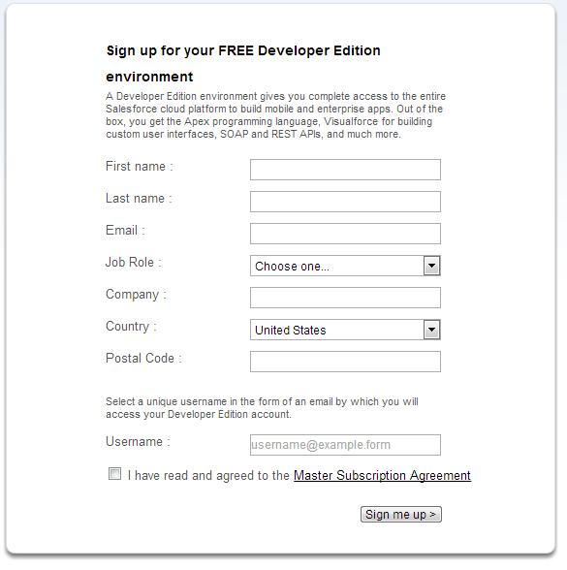

## Configuring the Cloud

In this case, we will be creating an SFDC Application and recreating some Cloud Objects to interact with our BlackBerry 10 mobile application. We will use existing SFDC standard objects and add some custom fields, as well as create some custom objects with custom fields for use in the app.

Breaking this all down into steps would look something like this:

1. Create SFDC Application
2. Create SFDC NameSpace
3. Object Definitions
   1. Modify SFDC standard
      1. Accounts
      2. Products
   2. Create Custom objects
      1. Volume
      2. Bar Rep
4. Working with Data in SFDC
   1. Make your SFDC sandbox look like ours
      1. Custom Object Tabs
   2. Add some test data
      1. Manual
      2. Data Import Wizard

And when all the configuring is all said and done, you should end up with an SFDC Schema that looks like this:

#### Orlando Brewing Data Schema

Finished Product (Data Model View)

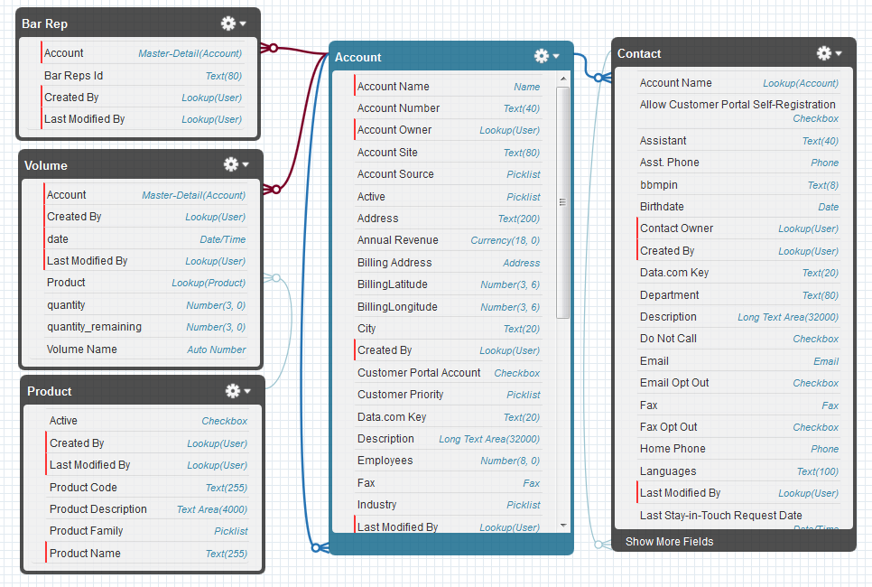

### Create SFDC Application

We will start off first by creating an SFDC application. So after you login, your left navigation pane should have a “Create” link with a submenu to “Apps”. Click the “New” button to get started. It’s a 5-step process and shown below.

Step Values:

1. Select Custom App
2. Enter the following values then click Next

App Label: OrlandoBrewing

App Name: OrlandoBrewing

Description: Whatever

1. Click Next to skip the custom app logo
2. Selected Tabs: Home, Contacts, Accounts, Products *(we will customize more later)*
3. Assign to Profiles: Doesn’t matter for this *(in production it would)* then click Save

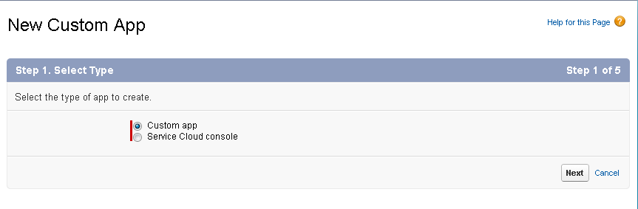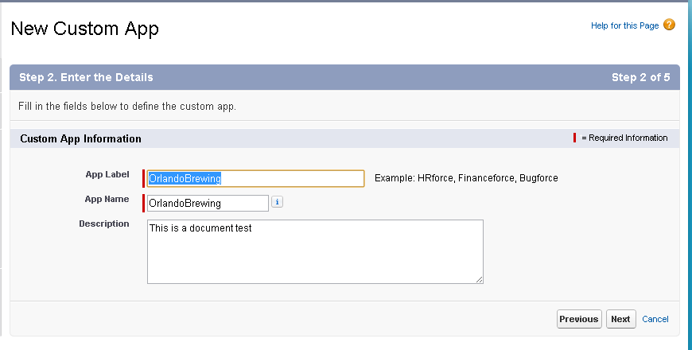

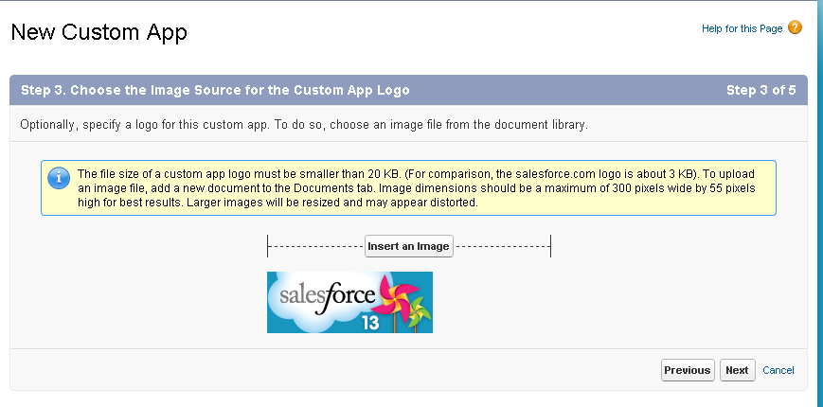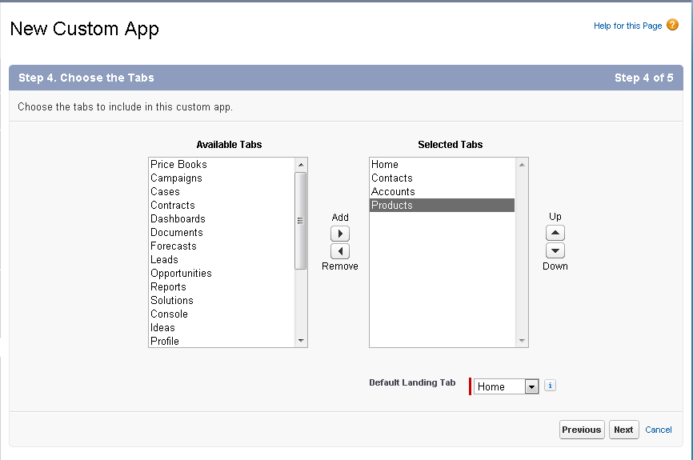

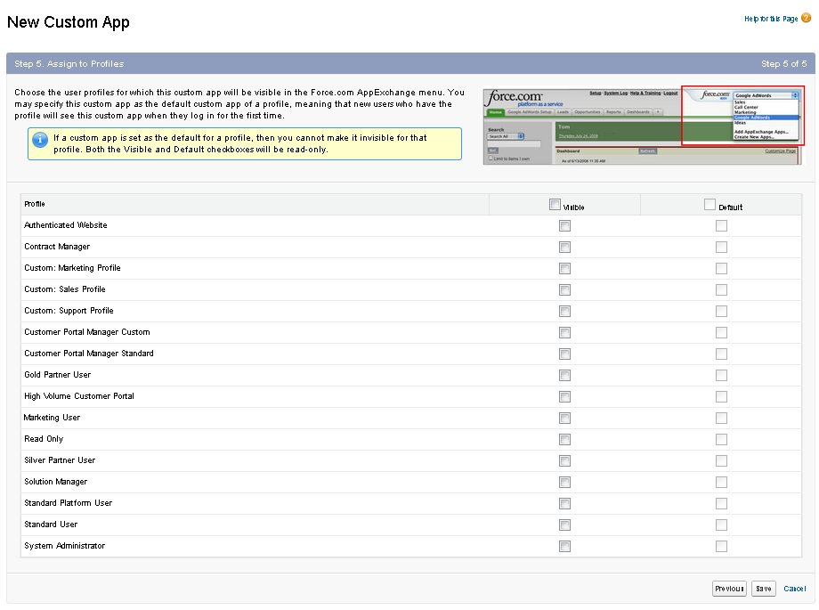

### Create SFDC NamesSpace

You will need to create a unique namespace that will also be used in the code base to ensure you are accessing your custom app. Go to App Setup->Create->Packages and edit your Developer Settings to select a namespace. The namespace you select must be unique across all other Salesforce apps (you will receive an error message if it is not). Once you have set your namespace, you will need to modify the global variable in “constants.h” in the mobile app to match your selected namespace. (see section below)

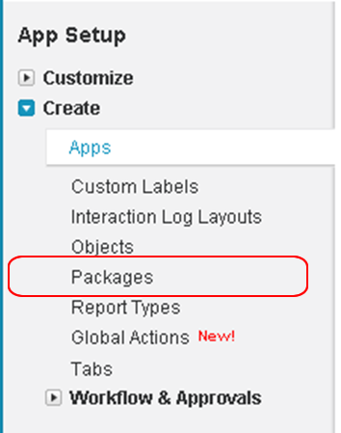

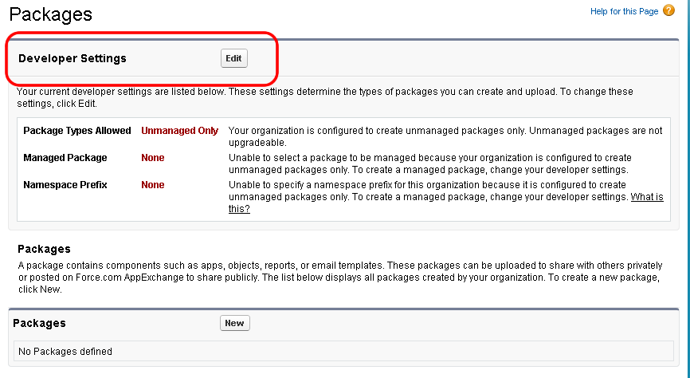

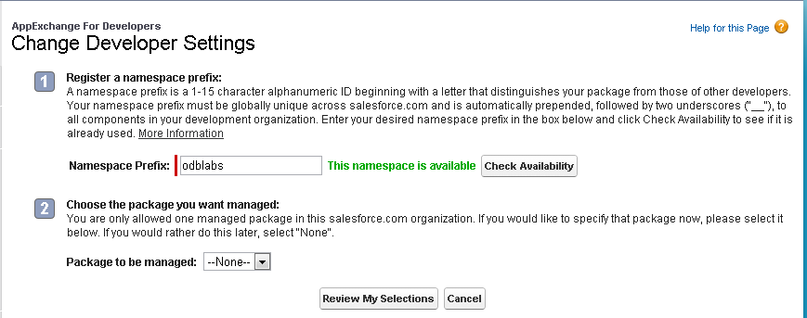

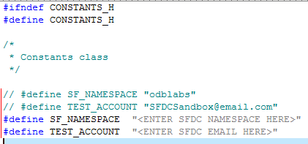

### Object Definition

Before you begin anything, you may want to delete the dummy data. Since there is not a lot of dummy data in there when we started, we skipped this step. But if you want to clean EVERYTHING, here is a link provided by SFDC on how to do so:

<https://help.salesforce.com/HTViewSolution?id=000005234&language=en_US>

But for getting this application demo going, we will have the following Objects defined in the app:

1. Account object will be used to store bar data. It is a Salesforce default object.
2. Product object will be used to store beer data. It is a Salesforce default object.
3. Contact object will be used to store the information of the representative at the Bar. It is a subset of the Account object.
4. Bar rep is used to allocate brewery representatives to individual bar accounts. This is a custom object.
5. Volume object will be used to keep track of beer quantities and capacities at a bar at some point in time. This is a custom object.

#### Account Object

We will only use Name, AccountNumber and Phone fields. To add the following custom fields to the Account object, select App Setup->Customize->Accounts->Fields. Go to the “Account Custom Fields and Relationships” section and click “new” to create a new field. 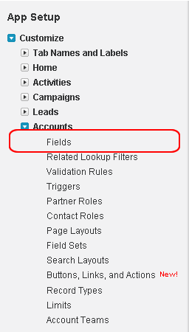 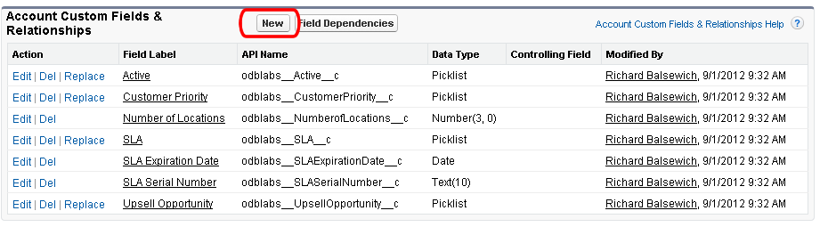

**For each field below, follow the creation wizard by selecting the appropriate data type and size. The wizard is between 4 and 6 steps depending on the “Data Type” in the table below.**

|  |  |  |
| --- | --- | --- |
| **Field Label** | **API Name** | **Data Type** |
| Address | *namespace*__Address__c | Text(200) |
| BillingLatitude | *namespace*__BillingLatitude__c | Number (***Data Length:3, Decimal Places: 6)*** |
| BillingLongitude | |  |  | | --- | --- | |  | *namespace*__BillingLongitude__c | | Number (***Data Length:3, Decimal Places: 6)*** |
| City | *namespace*__City__c | Text(20) |
| zipcode  ***(lower case)*** | *namespace*__zipcode__c | Text(8) |

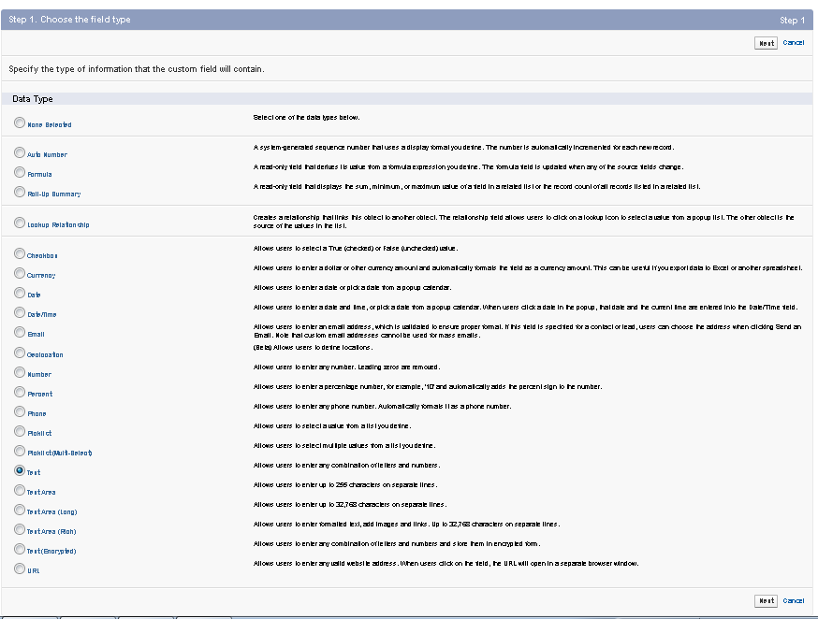

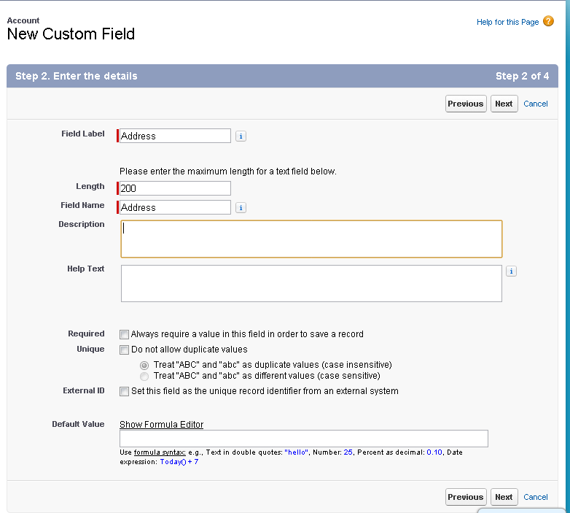

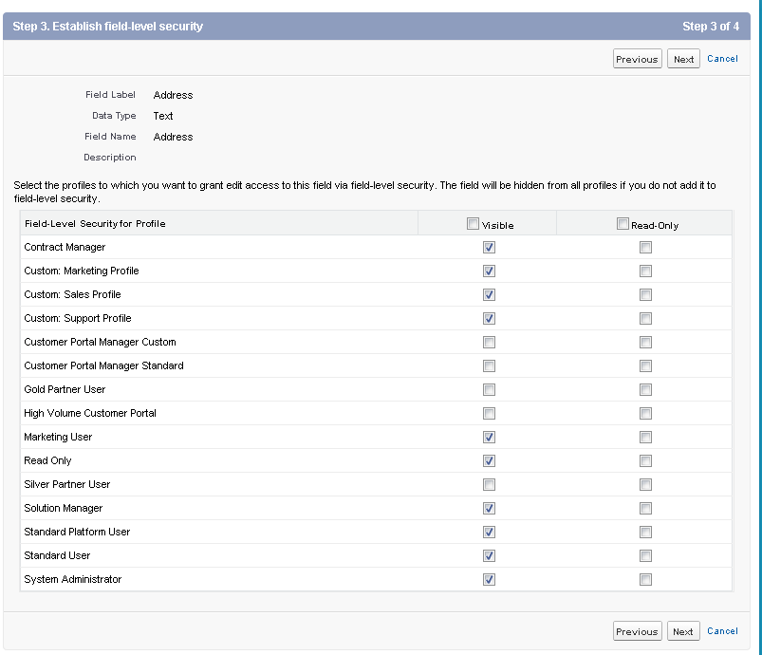

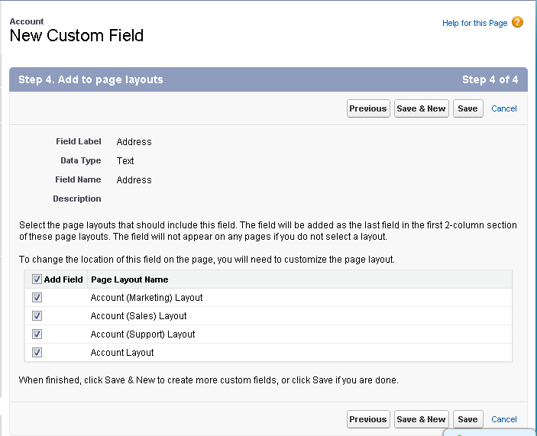

This is what the “Account Custom Fields and Relationships” area should look like when you’re all done with the modifications.

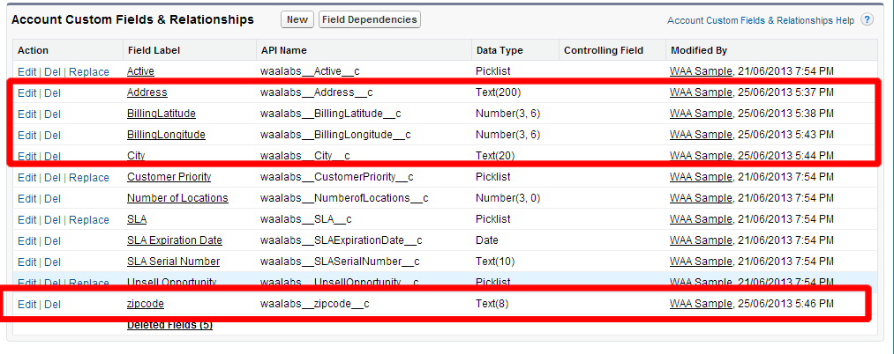

#### Product Object

Product object is used to store the beer data. We will use the Product Code and Product Name fields.

There are no modifications needed when working with the Product Object. We will manually create some products in section below.

#### Contact Object

Contacts may have one or more accounts related to it. We will use the Account and phone default fields. Add the following custom fields to this table:

|  |  |  |
| --- | --- | --- |
| **Field Label** | **API Name** | **Data Type** |
| bbmpin | *namespace*__bbmpin__c | Text(8) |
|  |  |  |

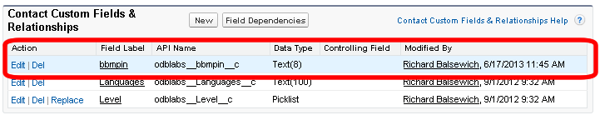

#### Bar Rep Object

For the Bar Rep Object, we will first create the object then the custom field. To create this object, go to “App Setup -> Create -> Objects”

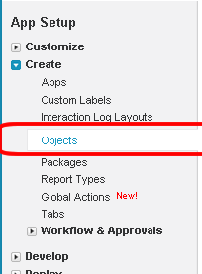

1. Create a new Bar Rep object with the following standard field. App Setup->Create->Objects

|  |  |  |
| --- | --- | --- |
| **Field Label** | **API Name** | **Data Type** |
| Bar Reps | Name | Text(80) |

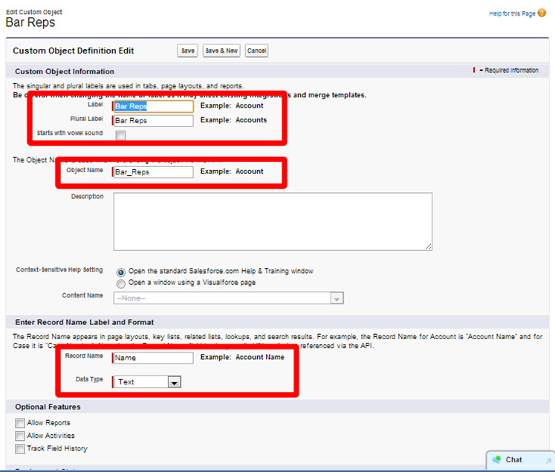

1. Add the following custom field to the “Bar Rep” custom object. To add this field is a 6 step process shown below.

|  |  |  |
| --- | --- | --- |
| **Field Label** | **API Name** | **Data Type** |
| Account | *namespace*__Account__c | Master-Detail(Account) |

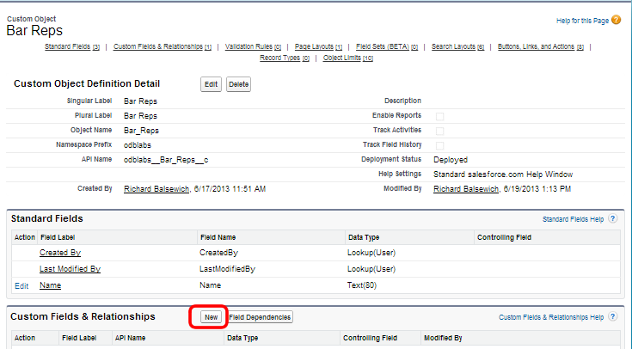

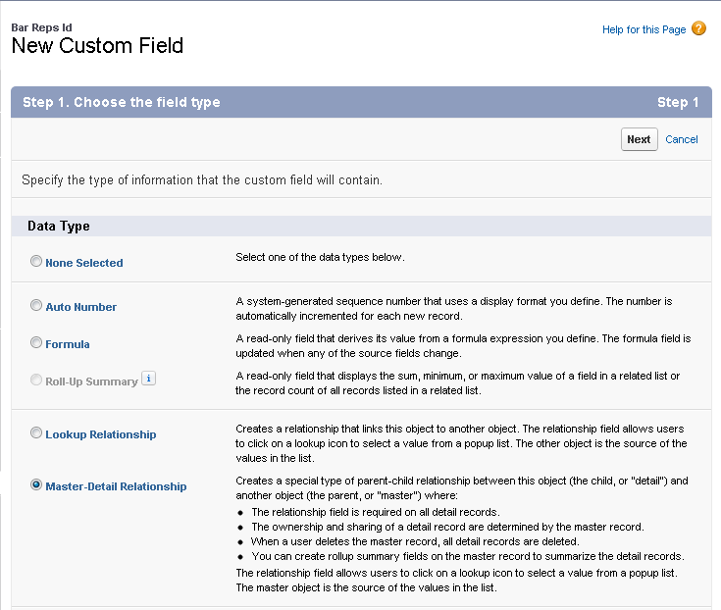

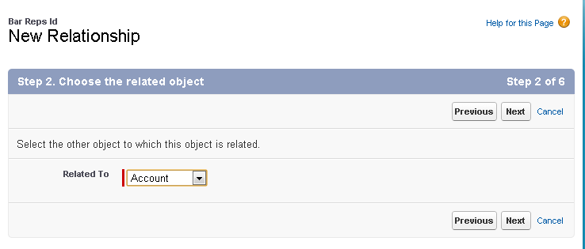

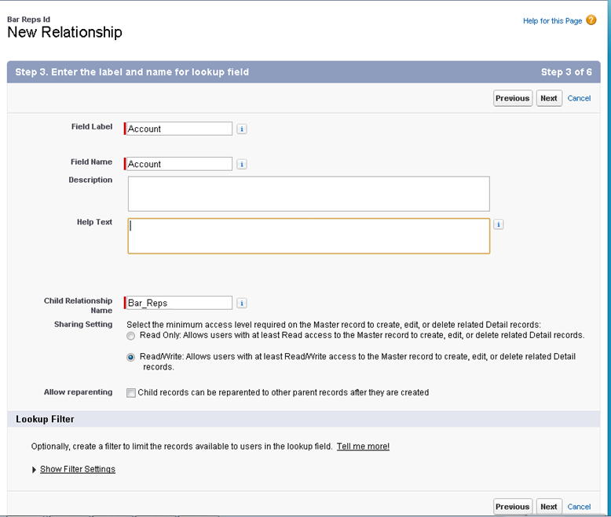

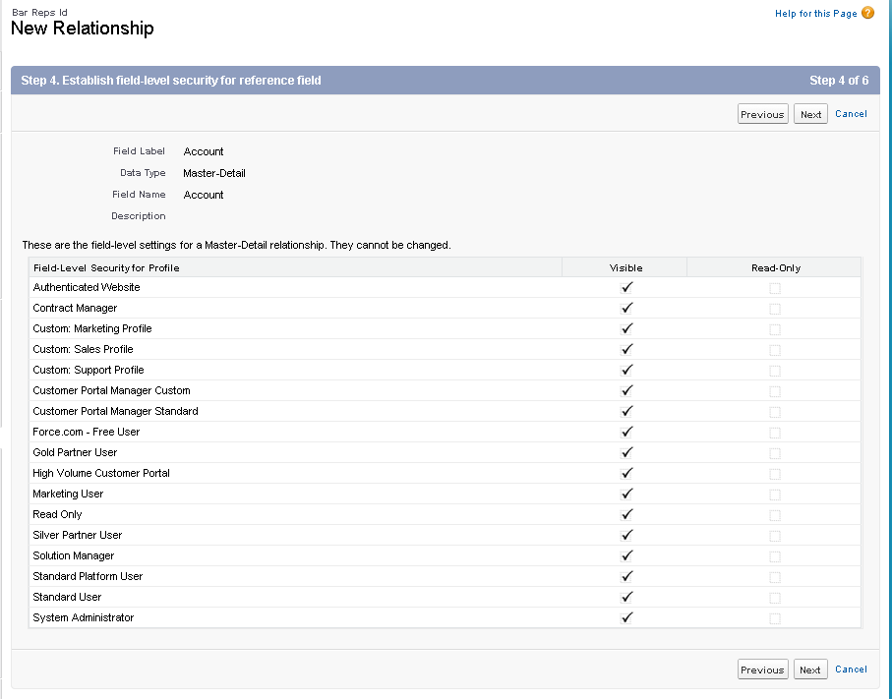

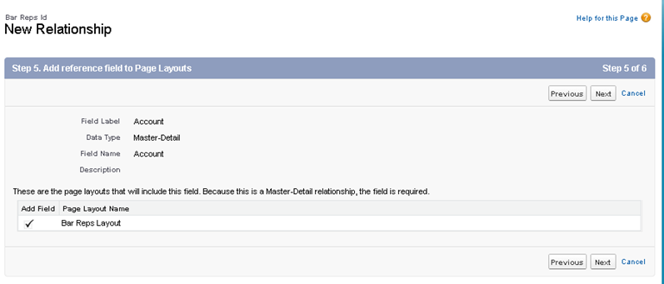

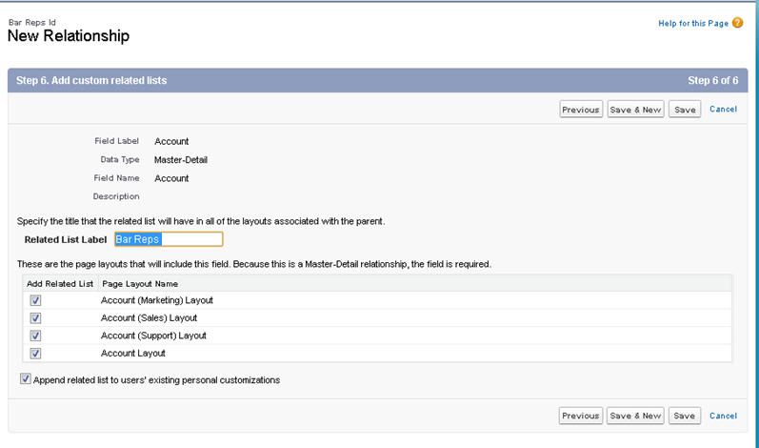

When finished your Bar Rep Id object should look like this:

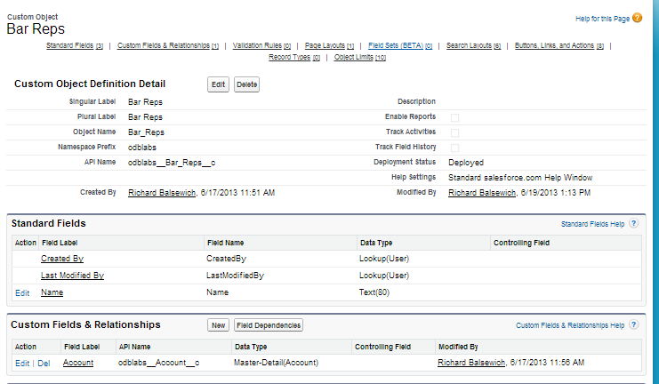

#### Volume Object

Create the custom Volume object following the same process as Bar Rep. Object first then add custom fields.

1. Create a new Volume object with the following standard field. App Setup->Create->Objects

|  |  |  |
| --- | --- | --- |
| **Field Label** | **API Name** | **Data Type** |
| Volume | Name | Auto-Number |



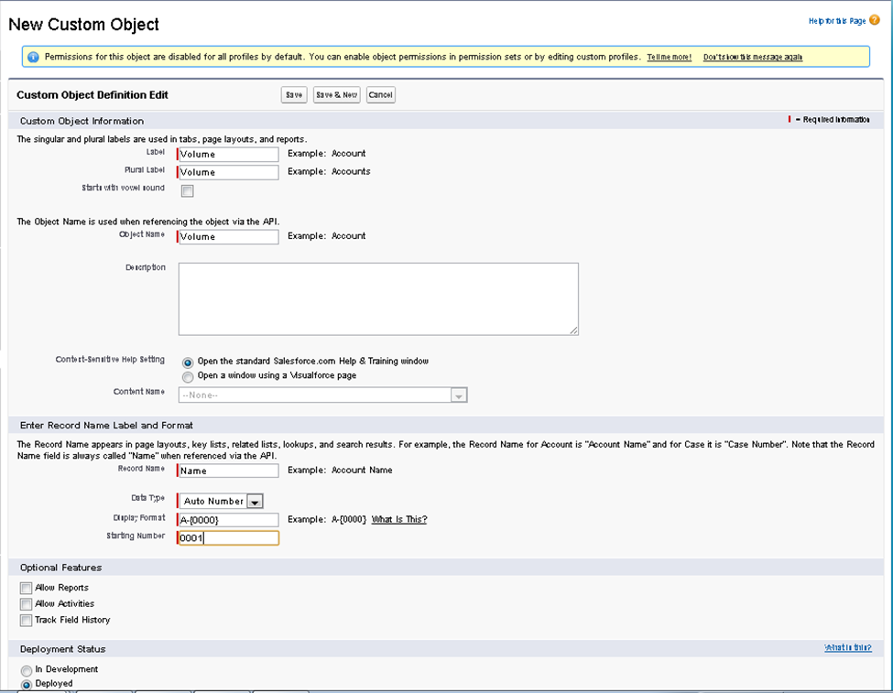

1. Add the following custom fields in the “Custom Fields & Relationships” section

|  |  |  |
| --- | --- | --- |
| **Field Label** | **API Name** | **Data Type** |
| Account | *namespace*__Account__c | Master-Detail ***(Related To: Account)*** |
| date | *namespace*__date__c | Date/Time |
| Product | *namespace*__Product__c | Lookup ***(Related To: Product)*** |
| quantity | *namespace*__quantity__c | Number(3, 0) |
| [quantity_remaining](https://na15.salesforce.com/00Ni0000003z6vx?setupid=CustomObjects) | *namespace*__quantity_remaining__c | Number(3, 0) |

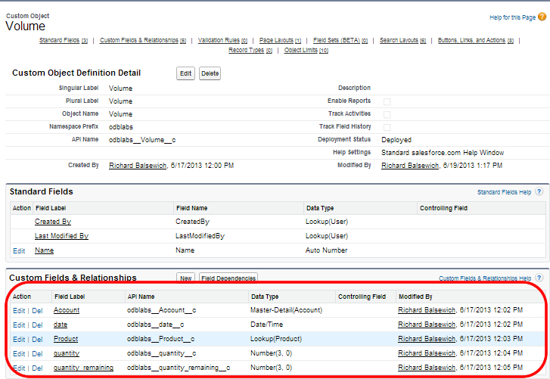

### Working with Data in SFDC

#### Setting up SFDC Environment - Visually

Alright so let’s setup your SFDC development environment so it looks like ours, it will make it much easier to enter some data moving forward for this sample.

1. Start by Creating Tabs for your Custom Objects:
   1. 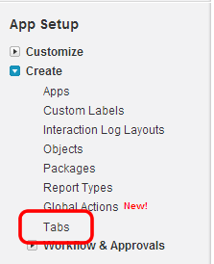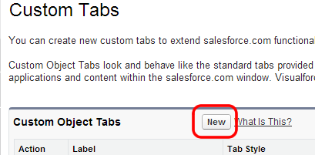
2. Create a custom tab for both the Bar Reps and Volume custom objects.
   1. Choose “Object”: *(e.g.: Bar Reps)* 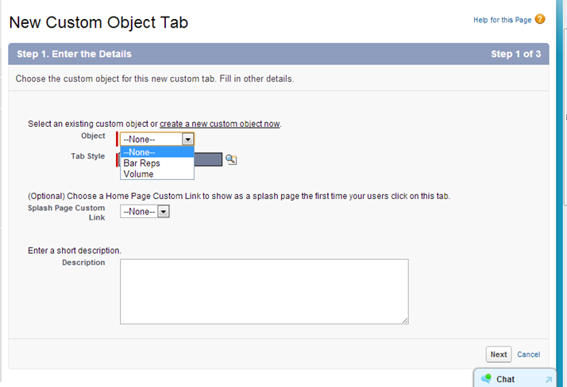
   2. Pick a “Tab Style”: 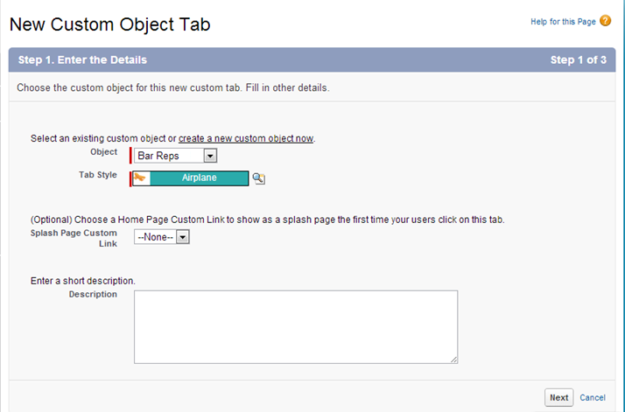
   3. Choose a Profile for Tab Availability: (default for me)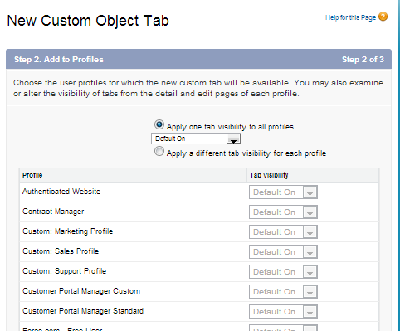
   4. Choose the Orlando Brewing App: (up to you)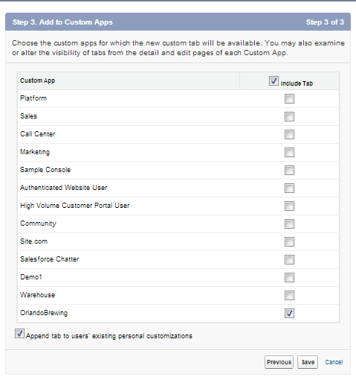
   5. Boom Done!

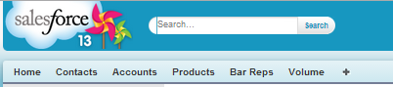

#### Adding Data to SFDC Environment – Manually

To get this sample going you’re going to need some sample data. With the recent change to the SFDC Data Import Wizard, these instructions can be used to manually enter data to get going quicker. Since we only have a few objects we’re working with it’s not a big deal.

You can reference the following project files for sample data:

#### Account Data

Sample account data. *See sample OrlandoBrewing_SalesForce_Accounts.csv*

#### Contact Data

Add at least one contact to each account record. *See sample OrlandoBrewing_SalesForce_Accounts.csv*

#### Product Data

Add different beers to the product table. *See sample OrlandoBrewing_Product_import.csv*

#### Volume Data

Add volume records for each product for each account. *See sample OrlandoBrewing_Volume_import.csv*

#### Bar Rep Data

Add Bar Rep data for each account. *See sample csv OrlandoBrewing_BarRep_import.csv. As well you will need to add the bar rep to the “constants.h” file.*

1. Start by adding some **PRODUCTS**, since they don’t have any required dependencies/relationships. Since we added a tab to our SFDC environment, it’s easy. (If you didn’t do this visit section above).
   1. 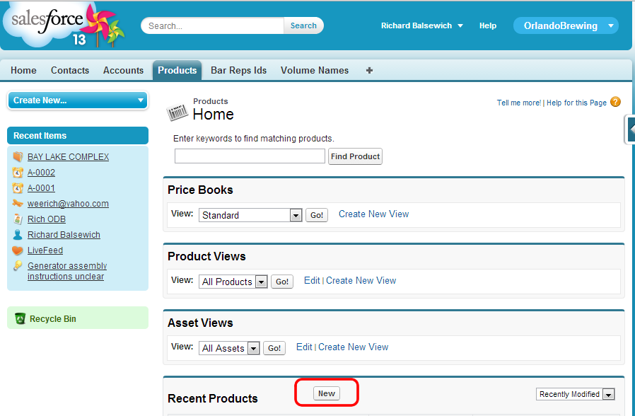
   2. Add **PRODUCTS** for (individually):
      1. Product Name: Blond Ale (Brown Ale, Olde Pelican, Pale Ale, Red Ale)
      2. Product Code: 100 (101,102,103,104)

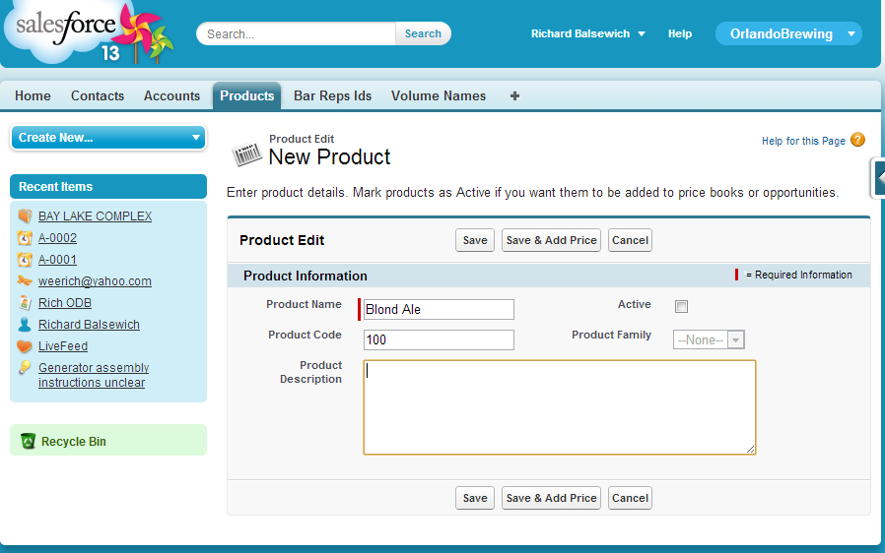

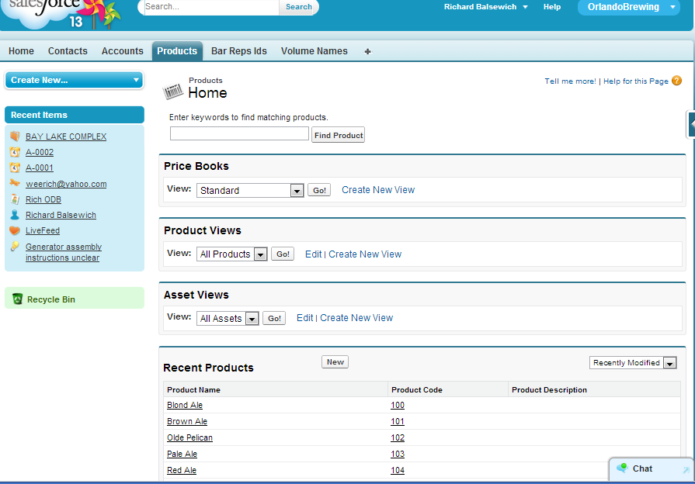

1. Add a new **ACCOUNT**. (You can click “Accounts” on the top menu bar.)
   1. Account Name: BAY LAKE COMPLEX
   2. BillingLatitude: 28.408615
   3. BillingLongitude: -81.586189
   4. 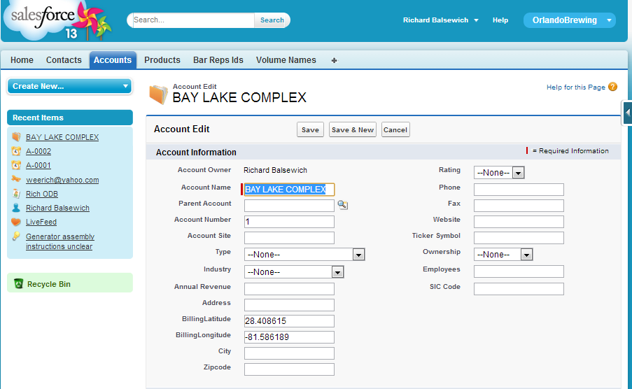
2. Add a new **CONTACTS.** . (You may need to click “+” on the menu bar to select “Bar Reps”.) The purpose of this is to tie a “Contact to an Account”. Click the new button and enter at minimum a “Last Name”. Make sure to use the “Search” icon to pick the Account.

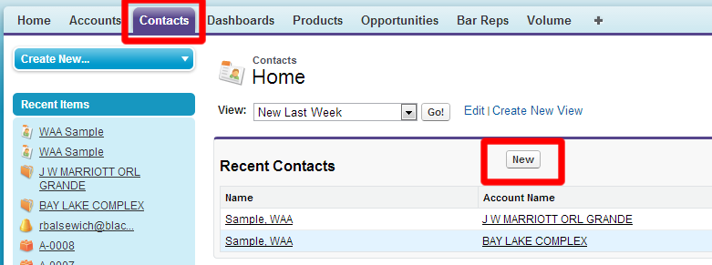

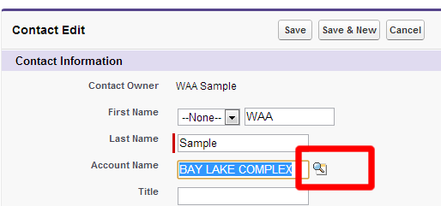

1. Add a new **BAR REPS**. (You may need to click “+” on the menu bar to select “Bar Reps”.) This should be the email address that you have tied to this SFDC dev environment. (Since this is all working in a sand box, that email is used for logging in from the client side for demo).

Also make sure to use the “Lookup” icon for “Account” field 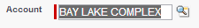

* 1. 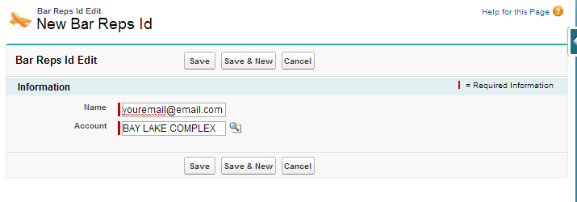

1. Add new “Volume Names”. (You may need to click “+” on the menu bar to select “Volume”.) This is inventory for our products. Make sure to use the “Lookup” feature for the “Account” and “Product”. You should create “Volume” for each of the “Products” we did in order to give our client app more to work with.
   1. 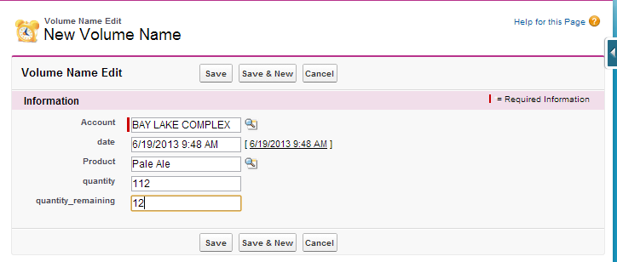

#### Adding Data to SFDC Environment – Data Import Wizard

SFDC offers a wizard for loading content into your Application. We have included some sample data files for use with the application you can try. The Import Wizard has recently been updated so screen shots could vary.

Click on “Setup” in the header. In the left navigation, expand “Data Management” and click “Data Import Wizard” the click “Launch Wizard”.

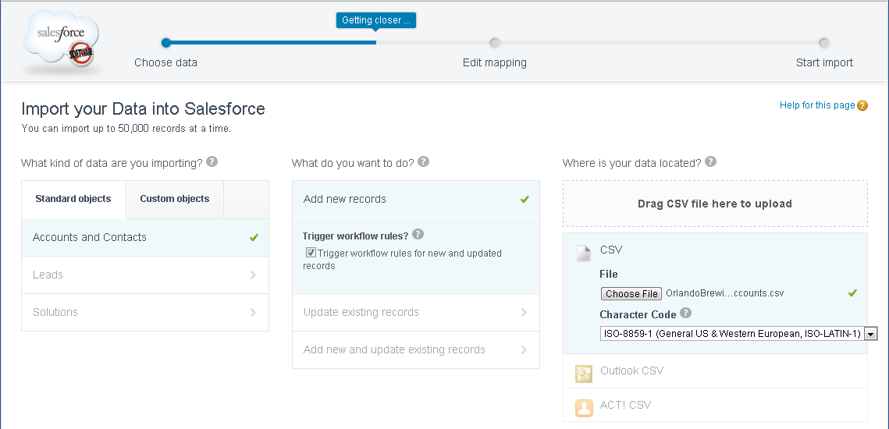

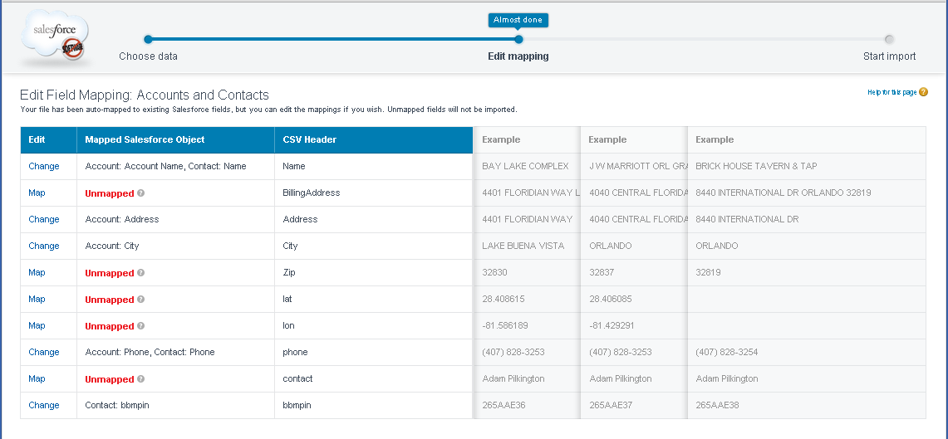

## REST API and Developer workbench

SFDC is a large customizable offering with several different enterprise-specific workflows. They provide several documents on how to leverage their cloud based services to deliver mission critical data. Use the REST API to query data that you created in the previous sections.

You can test your queries in the [developer workbench](https://workbench.developerforce.com/select.php) (Utilities -> REST Explorer).

# Setup BlackBerry 10 Sample Project

The BlackBerry 10 mobile application that accompanies this demonstration will need just a few modifications to sync up with the SFDC work you just completed. It is assumed you have an understanding of how to operate the BlackBerry Momentics IDE to import the project from Github. If not please refer to: <http://developer.blackberry.com/cascades>

At a high-level we will:

* 1. Import Project into IDE
  2. Updated Source Files
  3. Deploy and Test

## Import Project into IDE

Depending on how you have the source of the project will determine how you import the project. But the end results should be exactly the same. If for some reason your project tree does not look like the following, then something is wrong.

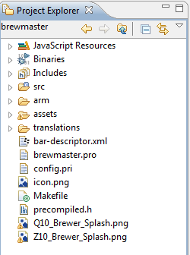

## Update Project Source

You will just need a few simple modifications before you can build and deploy this application. Definitely take some time to go through source to understand the interaction points and communication samples between the mobile client and SFDC cloud.

### Constants.h

This file is located under the “src” folder. You will need to update the “SF_NAMESPACE” to the one you configured above, and “TEST_ACCOUNT” field to be the email address you registered your SFDC development environment with.

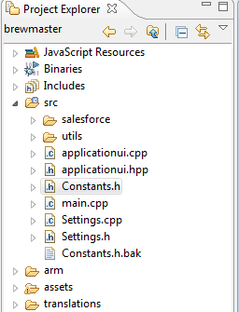

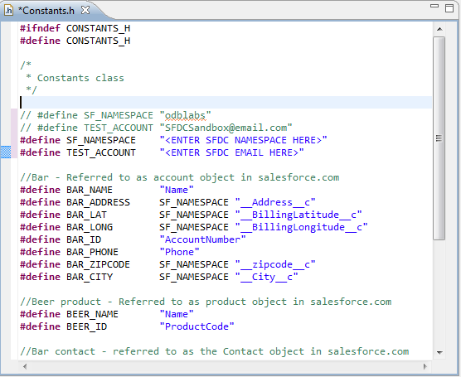

## Deploy, Test and Troubleshoot

When the application first launches, it should take you through the SalesForce.com login work flow. This authentication piece is what allows the mobile application to communicate back and forth with the SFDC cloud using oAuth2.0 token workflow. Since we the application is counting on correct configurations, you can add the following line to the main.cpp to enable console logging when running with a connected device.

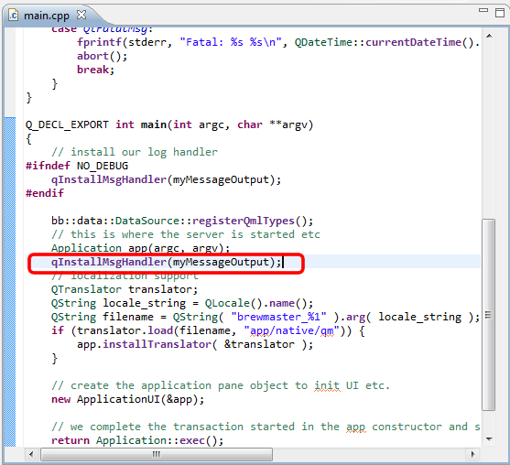

If you see an error like this, you have a typo in your custom object name. You can verify your “Select” statements in the ***VolumeRequest.cpp*** file.

\nERROR at Row:1:Column:251\nsObject type 'odblabs__Voluem__c' is not supported. If you are attempting to use a custom object, be sure to append the '__c' after the entity name. Please reference your WSDL or the describe call for the appropriate names.","errorCode":"INVALID_TYPE"}]"

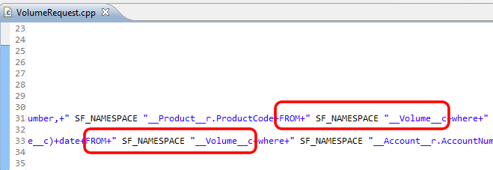

#### Otherwise

Your application should look something like this:

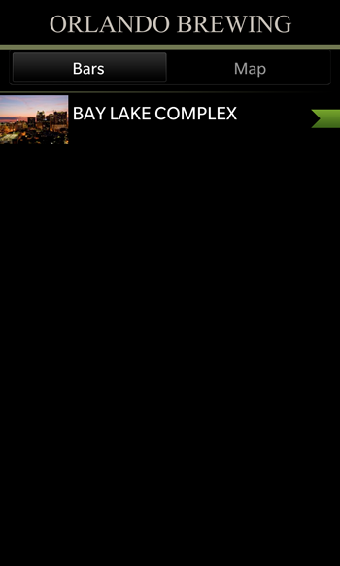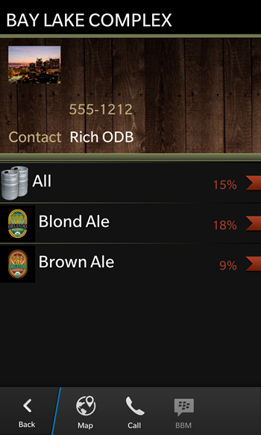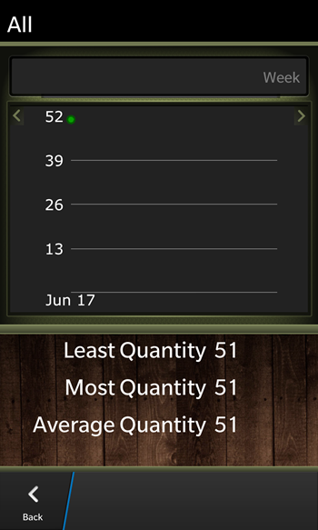

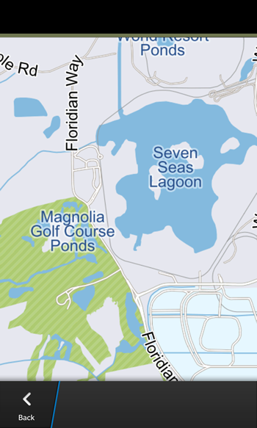

#### BONUS:

If you are receiving the following dialog when using different devices, SFDC allows you to configure a range of valid IP addresses to avoid the email verification code workflow. ***Note: This information was provided by SFDC when asked how to configure the SFDC dev environment to work with users sharing account login.***

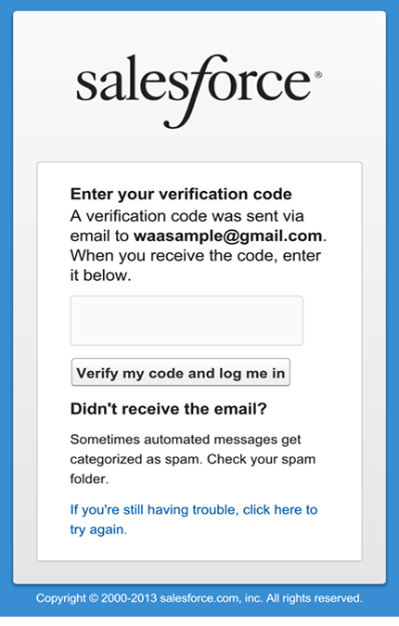

You can enter your domain IP range details to allow anyone using a device on that network to allow the “Connectivity” without having an email verification code workflow hurdle when sharing accounts.

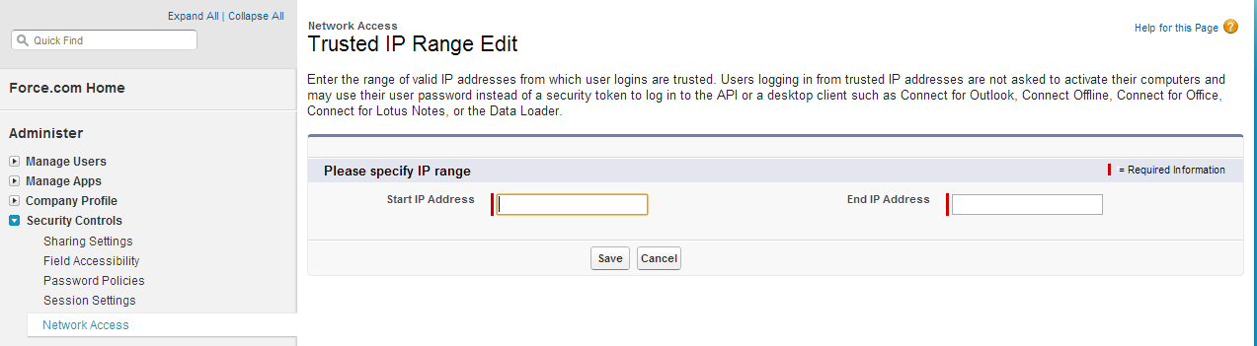

#### OPTIONAL IP RANGE CONFIGURATION:

For situations where the IP address ranges are unknown. The SFDC dev cloud allows for the user to create an IP range for a particular login profile. (e.g.: we are using a demo email address to access the SFDC cloud for multiple users, it’s a demo) This login profile can then not be subject to the email verification.

##### Step 1:

Go into the SFDC dev environment and check to see which “Profile” your user account is assigned. For the most part, when a developer creates an account it gets assigned to “System Adminstrator”.

This picture shows the [waasample@gmail.com](mailto:waasample@gmail.com) user account being assigned to the “System Administrator” profile.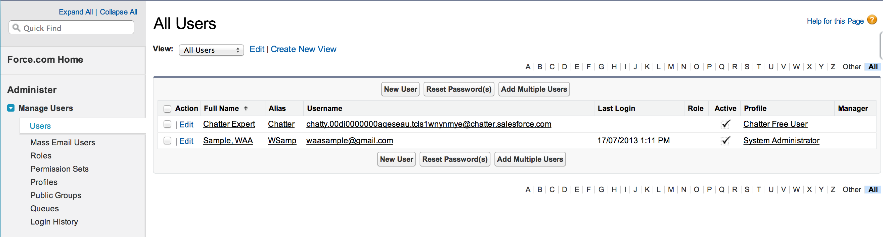

##### Step 2:

Once you have identified the user “Profile”. Use the MANAGE USERS -> Profiles left navigation item to display the list of profiles. Scroll down until you see the “Profile Name” that matches the one your user is assigned.

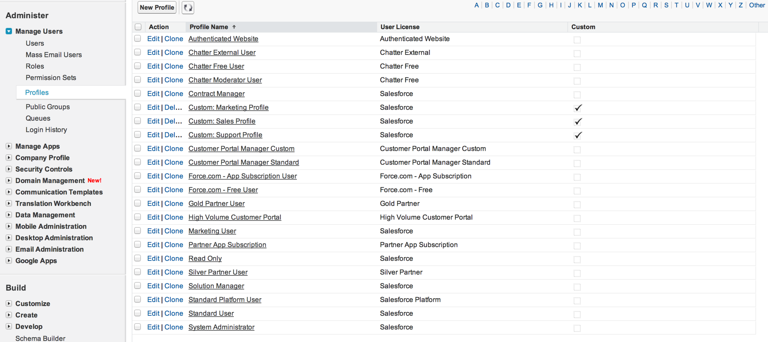

##### Step 3:

After selecting the “Profile Name”, scroll down until you see the “Login IP Ranges”. Here is where you will create your new range of IP addresses that SFDC dev cloud should expect your email address to login from. In this example, we are using the entire range of possible IP addresses (e.g.: 0.0.0.0 to 255.255.255.255)

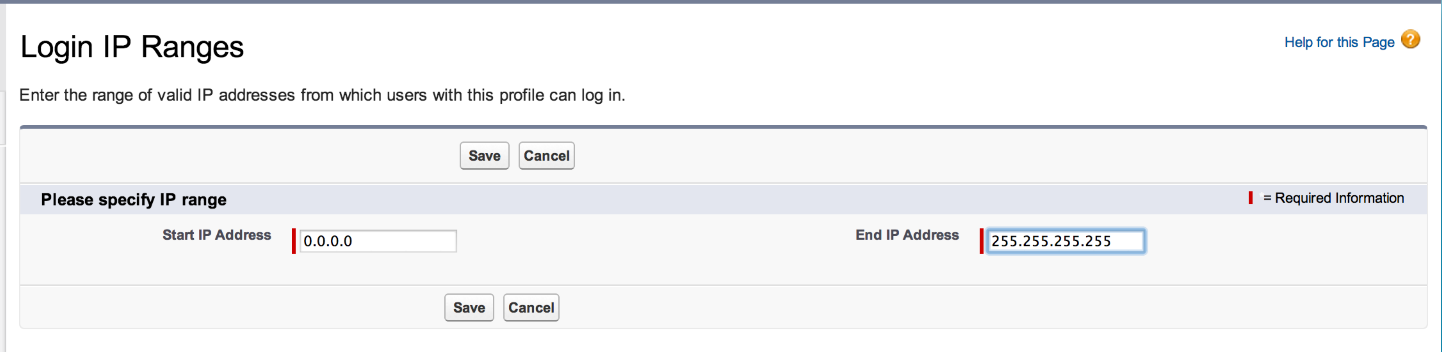

##### Step 4:

Once you save you should see it store for the user profile.



#### Build Errors:

You will probably notice some errors when building the project. They should only be JavaScript errors which have no impact on the operation of the application.

